**APC**head(sorted_data_APC, 3)

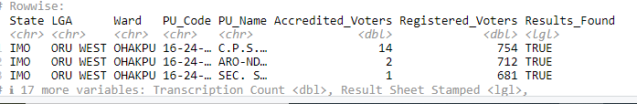

**LP**head(sorted_data_LP, 3)

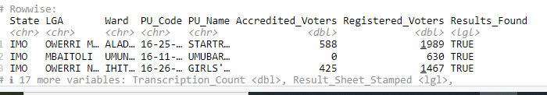

**PDP**head(sorted_data_PDP, 3)  
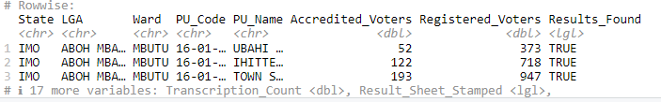

**NNPP**head(sorted_data_NNPP, 3)  
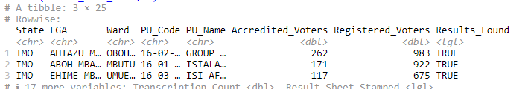

**# Visualization for APC**

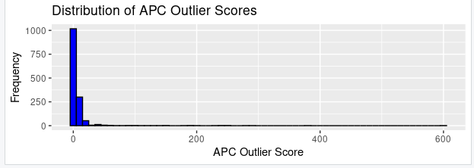

**# Visualization for LP** 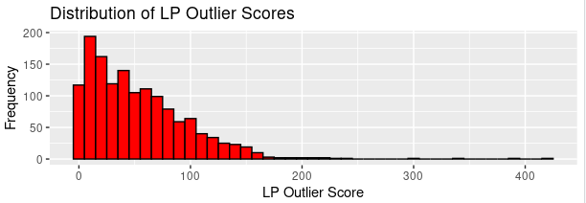

**# Visualization for PDP  
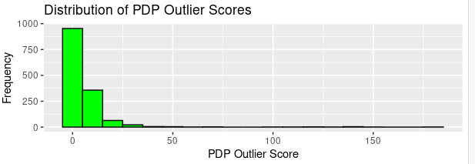**

**# Visualization for NNPP**

